Mahatma Gandhi –Philosophy on Sarvodaya

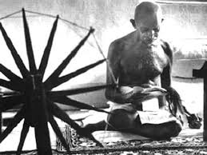
The present world is disconnected and full of pandemonium. Nobody wants to listen to others. The fire of hatred is burning internally but it is not visible externally. There is chaos all around with violence and injustice.

Now the question arises as to what should be the way out of this disruption? In the words of Mahatma Gandhi, there is only one way to solve this problem. That is to understand and cultivate the ideals of Sarvodaya. The happiness of human life lies in the application of the Sarvodaya ideals.

The word Sarvodaya is Sanskrit in origin. It is a portmanteau of two words “Sarva” which means “all” and “Udaya” means “upliftment”.

Sarvodaya aims for universal well being and there is no barrier between two individuals. Everyone should be respected and given their due share. Truth, nonviolence, self-sacrifice and spiritual tolerance are the main pillars of Sarvodaya. Sarvodaya adopts Satyagraha as a weapon of social change. Freedom, justice, equality and fraternity are part and parcel of Sarvodaya.

The ideals of Sarvodaya are extremely important in the 21st century due to the complexities of human behavior and interaction. It is perhaps the only way to solve the problems of unemployment, unequal distribution of wealth, growing corruption in public life and diminishing human values.

It is a guiding light for us which shows the right way towards freedom, peace and universal brotherhood.

