PhD openings in the Department of Biotechnology (2022-2023)
Faculty of Life and Allied Health Sciences, M.S.Ramaiah University of Applied Sciences

The Department of Biotechnology offers 4 PhD openings in the academic year 2022-2023. Details on the openings are listed below:
1) Name of the Guide: Dr Soma Chaki
Faculty profile: Associate Professor, Biotechnology
Research interest: Cancer Immunology
Tentative project titles:
- Study of possible correlation between tumor-infiltrating lymphocytes and cancer stem cells in oral squamous cell carcinoma
- Identification and characterization of inflammatory bio-markers in oral squamous cell carcinoma
Minimum course requirement for students: M.Sc. in Biotechnology/ Molecular Biology/ Biochemistry/Zoology; with basic practical skills in microscopy, electrophoresis, biochemical assays, basic idea on aseptic techniques, basic laboratory tools and techniques in molecular biology; NET, BET qualification desirable.
2) Name of the Guide: Dr. K. Prashanthi
Faculty profile and research interest: Cancer Metabolism
Tentative project title: Regulation of Cancer Metabolism (Breast Cancer)
Minimum course requirement for students: Students should have completed MSc Biotechnology/Biochemistry having scored greater than 70% in their Masters. They should have basic knowledge in Molecular biology, biochemistry techniques, bioinformatics. They should have done a project in their final year of MSc. The candidates having programming in R or python and experience in analysing gene expression data will be preferred. CSIR net qualification would be preferred.
3) Name of the Guide: Dr Swati Sinha
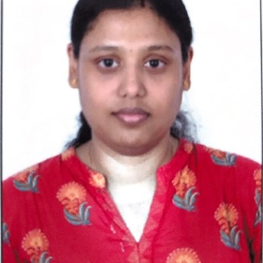
Faculty profile: Assistant Professor, Biotechnology
Research interest: Gliomagenesis , Alternative Cell Death Mechanisms
Tentative project titles:
a. Molecular Mechanism of Gliomagenesis: role of different cell types in brain.
b. Molecular mechanism of Gliomagenesis: role of tumour micro-environment.
Minimum course requirement for students: M.Sc. in Biotechnology/ Molecular Biology/ Biochemistry. Preferred Skills: Basic knowledge of Molecular biology, Microscopy and Animal cell culture techniques . CSIR-UGC NET qualification desirable.
4) Name of the Guide: Dr. Ekta Tripathi
Faculty profile: Assistant Professor, Dept of Biotechnology
Research interest: Cancer Biology and Telomere biology
Tentative project title: Telomerase regulation in breast cancer
Minimum course requirement: M.Sc. in Biotechnology/ Molecular Biology/ Biochemistry. Preferred Skills: Basic molecular biology techniques (PCR, cloning, electrophoresis) and basic cell culture techniques. CSIR-UGC NET qualification desirable.

